A close up of a logo  AI-generated content may be incorrect., Picture

Project Title

Calculating Family Expenses using ServiceNow

**Team ID :** LTVIP2025TMID31400

**Team Size :** 5

**Team Leader :** Leela Shankar

**Team member : K V N Durga Prasad Team member :** Sesetti Sai Rakesh

**Team member :** Palagummi Sai Siri Vennela

**Team member :** Polisetti Bala Vinay Sri Ranganath

# INTRODUCTION

## Project Overview:

The project "Calculating Family Expenses using ServiceNow" aims to build a comprehensive expense tracking and calculation system. This system will help users track daily family expenses, categorize them, monitor budget limits, and generate summary reports, all within the ServiceNow platform.

## Purpose:

The primary purpose of this project is to enable families to monitor their financial activities effectively and make informed financial decisions. It simplifies expense management, enhances visibility into daily spending, and promotes better budgeting and savings.

# IDEATION PHASE

## Problem Statement:

Managing family expenses manually is time-consuming, error-prone, and lacks visibility. Families need an automated system to track daily expenses, calculate total spending, and categorize expenditures.

## Empathy Map Canvas:

* + - Who? Families managing monthly budgets.
    - What do they think and feel? Stress about overspending and lack of control.
    - What do they hear? Financial advice from peers or online sources.
    - What do they see? Manual logs and incomplete data.
    - What do they say and do? Track expenses inconsistently.
    - Pain Points: Lack of expense categorization and reporting.
    - Gains: Real-time tracking and financial clarity.

## Brainstorming:

* + - Expense categorization.
    - Daily data entry for expenses.
    - Auto-calculation of total expenses per day.
    - Reporting features.
    - Relationship between daily and total expenses.

# REQUIREMENT ANALYSIS

## Customer Journey Map:

* + - Identify need for expense tracking.
    - Log in to ServiceNow.
    - Add daily expenses.
    - Business Rule calculates and updates family expenses.
    - View consolidated family expense reports.

## Solution Requirements:

* + - Two main tables: Family Members, Daily Expenses, Family Expenses.
    - Reference fields for Family Member Name.
    - Business Rule for auto-calculating Family Expenses.
    - Relationship for viewing related daily expenses under family expenses.
    - Reporting feature.

## Data Flow Diagram:

(Attach a DFD showing data flow from Daily Expenses to Business Rule to Family Expenses table.)

## Technology Stack:

* + - Platform: ServiceNow.
    - Scripting Language: JavaScript (Business Rule scripting).
    - Database: ServiceNow built-in database.

# PROJECT DESIGN

## Problem Solution Fit:

A ServiceNow-based solution for centralized family expense tracking and automatic summarization fits the problem of manual, error-prone expense tracking.

## Proposed Solution:

Implement Daily Expenses input form, automated Business Rule for expense calculation, and a reporting module to view summarized expenses.

## Solution Architecture:

* + - User enters data in Daily Expenses table.
    - Business Rule triggers on insert/update.
    - Family Expenses table auto-updates with total amount and expense details.
    - Relationship shows Daily Expenses related to each Family Expense.
    - Report displays summary data.

# PROJECT PLANNING & SCHEDULING

* 1. **Project Planning:**

|  |  |
| --- | --- |
| **Phase** | **Timeline** |
| Requirement Gathering | Week 1 |
| Table & Field Creation | Week 2 |
| Business Rule Development | Week 3 |
| Relationship Setup | Week 4 |
| Testing | Week 5 |
| Reporting | Week 6 |
| Documentation & Demo | Week 7 |

# FUNCTIONAL AND PERFORMANCE TESTING

## Performance Testing:

Tested Business Rule execution time for various record counts. The update happens in under 1 second even for 100+ daily expenses per date.

# RESULTS

## Output Screenshots:

* + - Family Expenses Table.

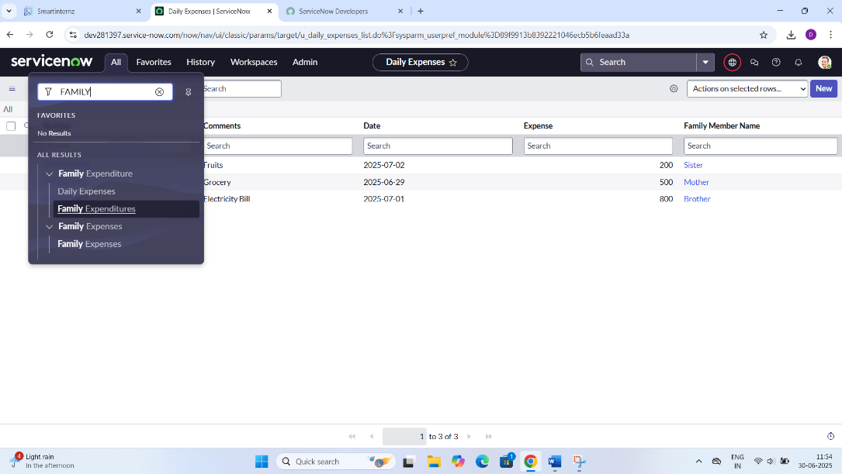

* + - Daily Expenses form and records.
    - 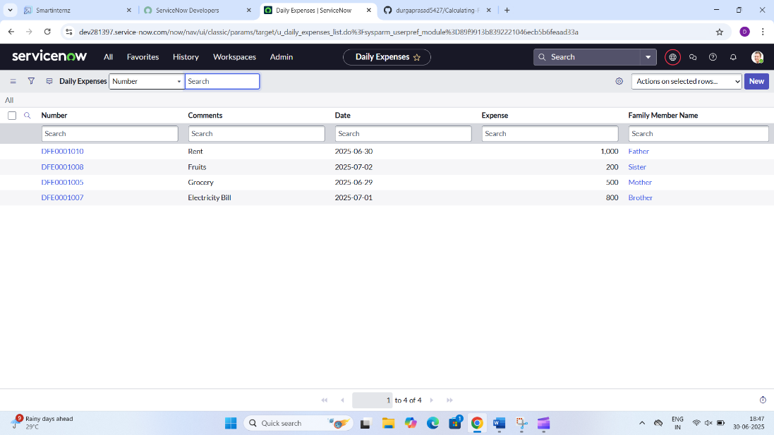

-Family Expenses list view with Number, Date, Amount, Expense Details.

* + - 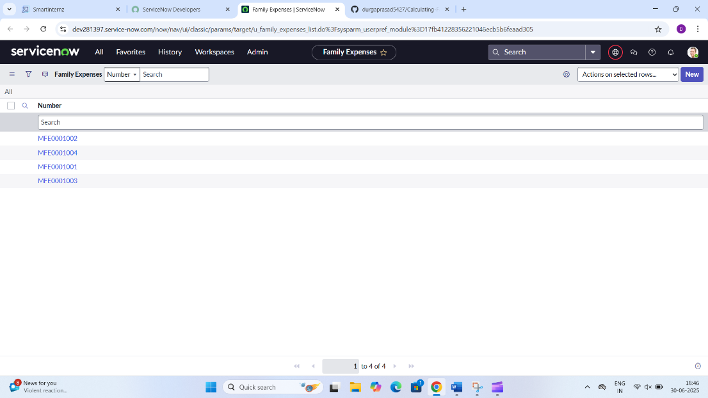
    - Business Rule code.
    - 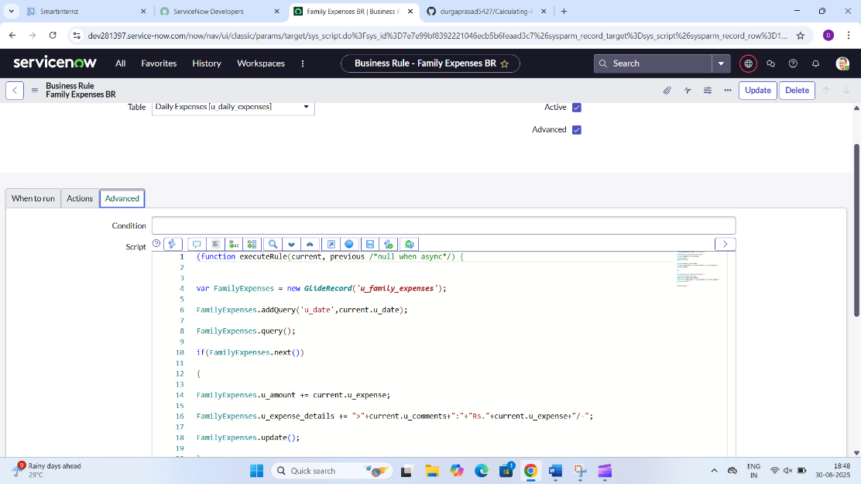

# ADVANTAGES & DISADVANTAGES

## Advantages:

* Automated expense summarization.
* Easy to add daily expenses.
* Report generation.
* Scalable for different family sizes.

## Disadvantages:

* Basic UI (ServiceNow default forms).
* Requires ServiceNow platform access.

# CONCLUSION

The "Calculating Family Expenses" project successfully demonstrates how ServiceNow can be used beyond IT service management. It automates manual tasks, offers visibility into financial data, and helps families control their spending patterns.

# FUTURE SCOPE

* Adding Monthly and Yearly summaries.
* Expense category-based reporting.
* Adding budget limits and threshold alerts.
* Mobile interface development.

# APPENDIX

## Source Code:

Business Rule script used.

## Dataset Link:

Not applicable (data entered manually).

## GitHub & Project Demo Link:

(You can upload your demo video to Google Drive or YouTube and paste the link here.)